Lifestyle & Fitness in Sportswear

All contestants will be required to wear a Miss Massachusetts’ Outstanding Teen fitness shirt that will be available to purchase for $25.00. The style of the shirt will either be a “tank top” similar to the one that was worn at last year’s State Pageant (see photos below) or a more fitted yoga-style, full-coverage style crop top. We are currently exploring different options for shirts.

** Please Note: At the National Competition, contestants MAY BE required to wear a crop top fitness outfit as they have for the two out of the past three years.

Bottoms and sneakers will be provided by the contestant.

CAPRI-LENGTH YOGA PANTS: Contestants must wear solid black fitness Capri’s (yoga pants). Please make sure that the Capri’s are calf length (not full length), are solid black, fitted and are not see-through! Stage lights are not kind, so make sure that your pants are made of a thicker-blend material and your undergarments are not visible. You MUST wear a black or white sports bra under your tank/top.

State Pageant National Pageant
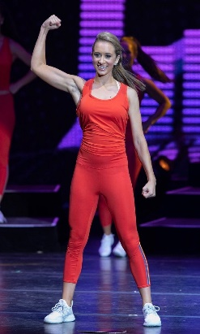


Rachel Perry Miss Massachusetts’ Outstanding Teen 2019/2020

SNEAKERS: Sneakers must be (primarily) white and be either athletic or Keds style and if not new, should be clean and presentable for wearing on-stage. Please wear white no-show athletic socks with your sneakers.

Please fill out and return the only the Order Form on page 2 with your $25 check made payable to Miss Massachusetts Scholarship Foundation.

Fitness Competition Order Form

FITNESS TOP ORDER FORM
Sizes Available: S, M, L, XL

Contestant Name:
Size:

_____ Small

_____ Medium

_____ Large

_____ X-Large

Price: $25.00

Please make a separate check or money order payable to:
Miss Massachusetts Scholarship Foundation
and enclose with this order form.

